Jibebe Internship 2022

# Progress report

Name: ADHO MAMO

## Tasks completed last week

* [#15] Redesign of the chassis drawing- Redesigning of the chassis drawing was done using the AutoCAD software so as to have dimension tolerance for good printing.
* [#22] Laser cutting of the chassis- Brief overview of the laser cutting machine and the Corel draw software was done. The design of the chassis drawing was imported to the Corel draw software and the laser cutting machine was used to cut out the chassis and its parts from the extruded acrylic material.
* [#23] 3D design of the chassis and the motor mounts- designing of the chassis and the motors was done using the SolidWorks software. This will be used to lock the motors to the chassis and also to join the bottom and the top chassis using fasteners.

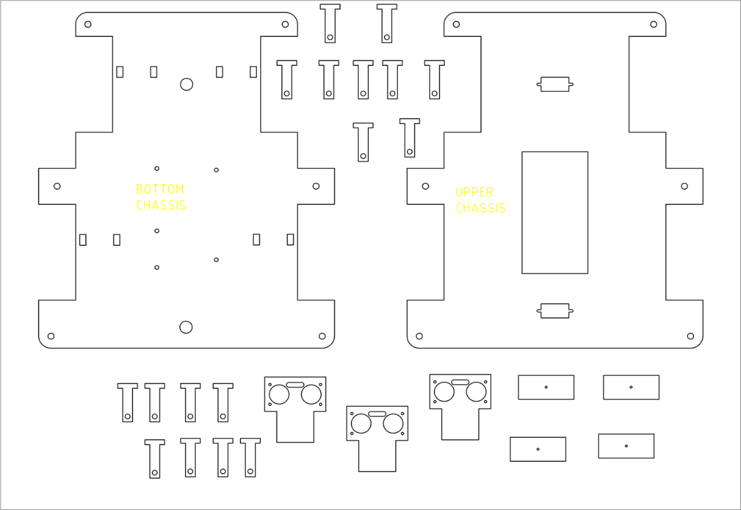

Figure 1chassis drawing

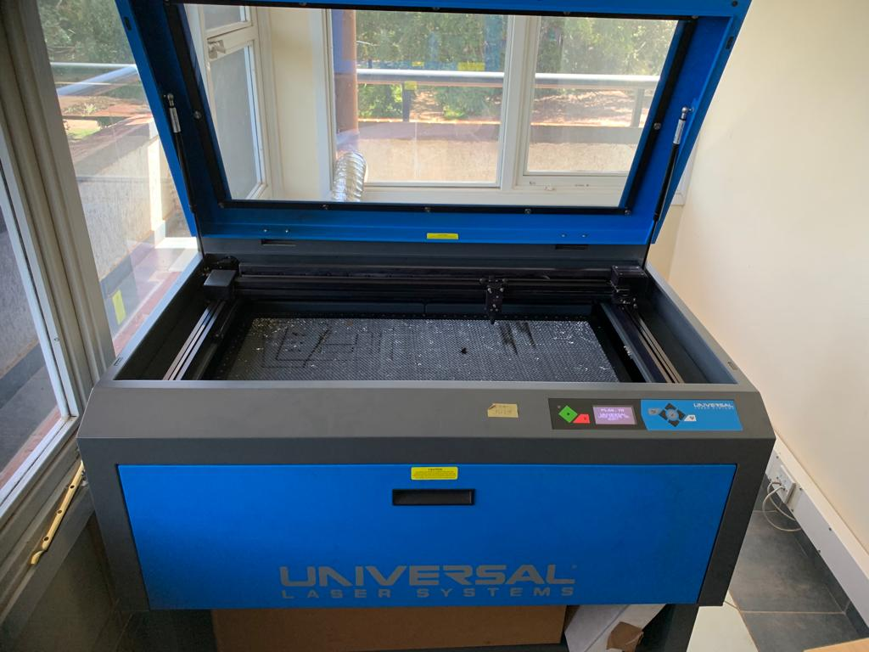

Figure 2 laser cutting machine

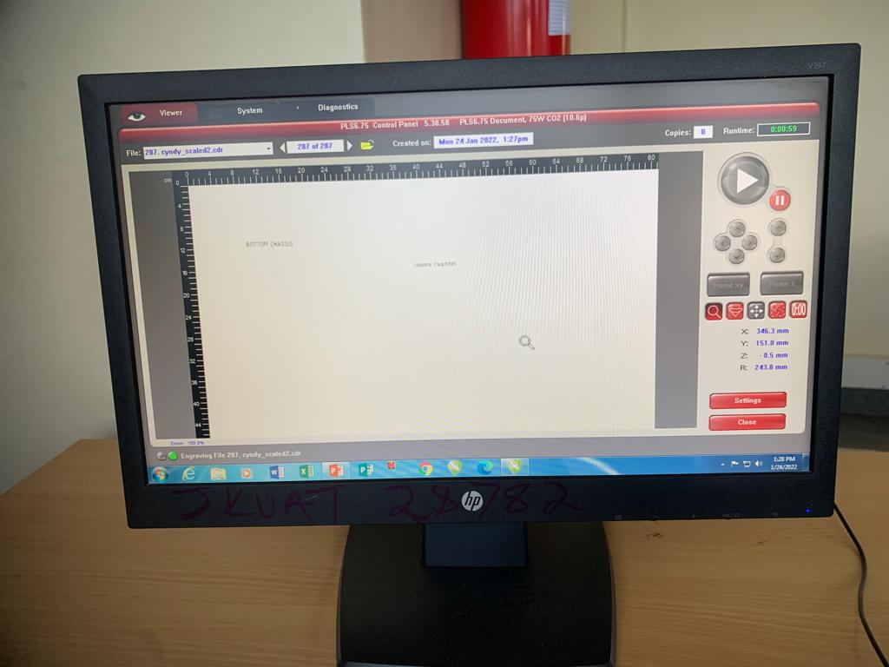

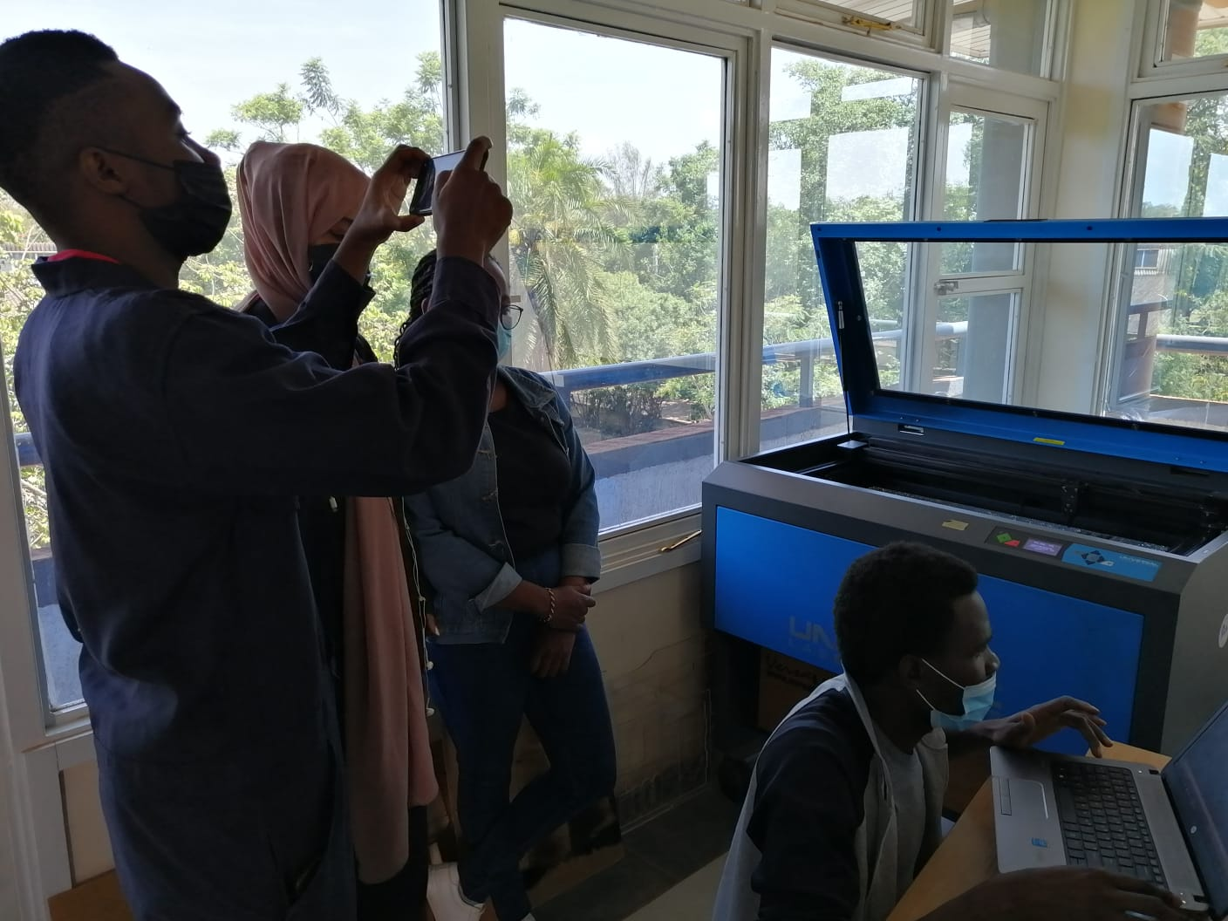



Figure 3 chassis holders

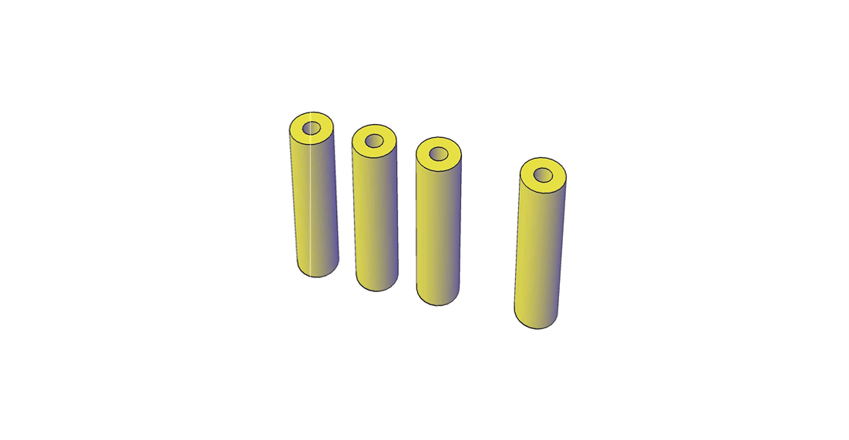

Figure 4 motor holders

## Tasks in this week

* [#24] 3D printing of the motor mounts
* [#25] obstacle avoidance using ultrasonic sensor
* [#26] obstacle avoidance using computer vision
* [#29] Material selection for 3D printing

## Timeline

|  |  |  |
| --- | --- | --- |
| Month | Intern week | Tasks |
| Jan |  |  |
| Week 1 | Identification of parts and drawing of the chassis diagram. |
| Week 2 | Circuit diagram and acquisition of parts. |
| Week 3 | Definition of the path to be followed by the robot car.  Laser cutting of the parts. |
| Feb | Week 4 | 3D printing of chassis and motor mounts  Redesigning of the chassis. |
| Week 5 | Assembling of components. |
| Week 6 | Designing of the farm implements to be used. |
| Week 7 | Testing the functionality of the Robot tractor and make necessary changes. |
|  | Week 8 | Have a Robot tractor that accomplishes the required mission, which is navigation and tillage. |
|  |  |  |
|  |  |  |
|  |  |  |
|  |  |  |
|  |  |  |
|  |  |  |
|  |  |  |